2. Sparse Matrix in Data Structure

What is sparse matrix explain?
Sparse matrices are those matrices that have the majority of their elements equal to zero. In other words, the sparse matrix can be defined as the matrix that has a greater number of zero elements than the non-zero elements.

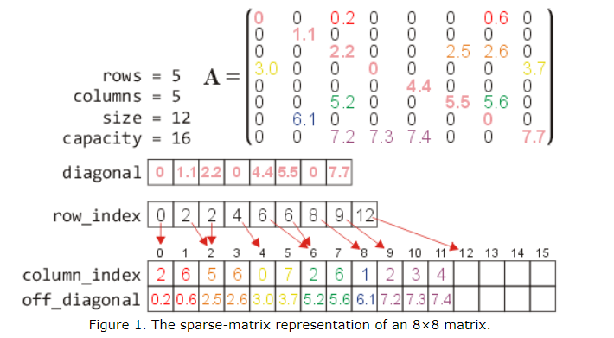

How to Create a Sparse Matrix in Python?

If most of the elements of the matrix have 0 value, then it is called a sparse matrix. The two major benefits of using sparse matrix instead of a simple matrix are:

- Storage: There are lesser non-zero elements than zeros and thus lesser memory can be used to store only those elements.

- Computing time: Computing time can be saved by logically designing a data structure traversing only non-zero elements.

Sparse matrices are generally utilized in applied machine learning such as in data containing data-encodings that map categories to count and also in entire subfields of machine learning such as natural language processing (NLP).

Example:

0 0 3 0 4
0 0 5 7 0
0 0 0 0 0
0 2 6 0 0
Representing a sparse matrix by a 2D array leads to wastage of lots of memory as zeroes in the matrix are of no use in most of the cases. So, instead of storing zeroes with non-zero elements, we only store non-zero elements. This means storing non-zero elements with triples- (Row, Column, value).

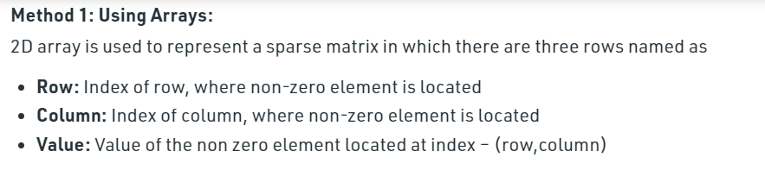
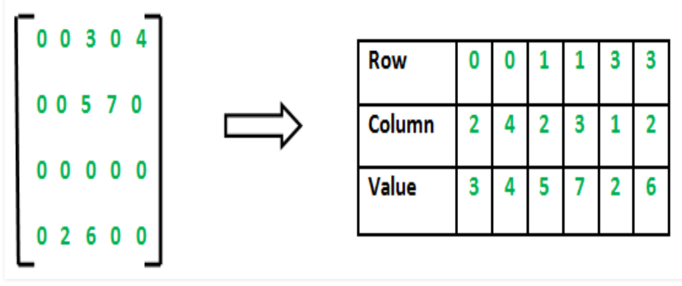
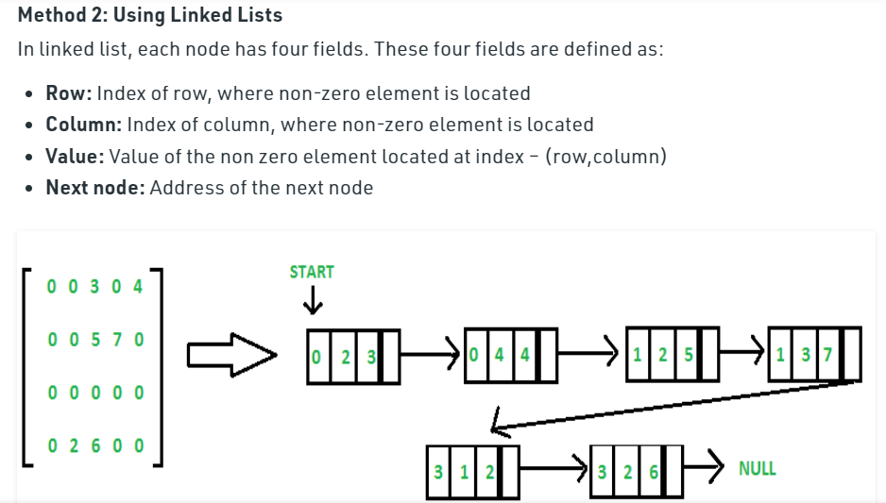

Example-1
# Python program to create
# sparse matrix using csr_matrix()
# Import required package
import numpy as np
from scipy.sparse import csr_matrix
# Creating a 3 * 4 sparse matrix
sparseMatrix = csr_matrix((3, 4),
dtype = np.int8).toarray()
# Print the sparse matrix
print(sparseMatrix)

Output:

[[0 0 0 0]
[0 0 0 0]
[0 0 0 0]]

Example 2:
# Python program to create
# sparse matrix using csc_matrix()
# Import required package
import numpy as np
from scipy.sparse import csc_matrix
row = np.array([0, 0, 1, 1, 2, 1])
col = np.array([0, 1, 2, 0, 2, 2])
# taking data
data = np.array([1, 4, 5, 8, 9, 6])
# creating sparse matrix
sparseMatrix = csc_matrix((data, (row, col)),
shape = (3, 3)).toarray()
# print the sparse matrix
print(sparseMatrix)
Output:

[[ 1 4 0]
[ 8 0 11]
[ 0 0 9]]

