5. Graph Connectivity

Biconnected graph

An undirected graph is called Biconnected if there are two vertex-disjoint paths between any two vertices. In a Biconnected Graph, there is a simple cycle through any two vertices.
By convention, two nodes connected by an edge form a biconnected graph, but this does not verify the above properties. For a graph with more than two vertices, the above properties must be e there for it to be Biconnected.
Or in other words:
A graph is said to be Biconnected if:
1. It is connected, i.e. it is possible to reach every vertex from every other vertex, by a simple path.
2. Even after removing any vertex the graph remains connected.
Following are some examples.
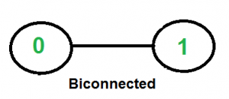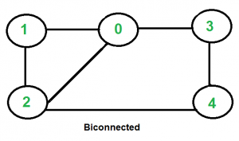

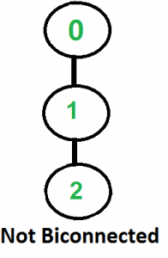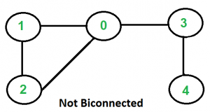

A connected graph is Biconnected if it is connected and doesn’t have any Articulation Point. We mainly need to check two things in a graph.
1) The graph is connected.
2) There is not articulation point in graph.

We start from any vertex and do DFS traversal. In DFS traversal, we check if there is any articulation point. If we don’t find any articulation point, then the graph is Biconnected.
Finally, we need to check whether all vertices were reachable in DFS or not. If all vertices were not reachable, then the graph is not even connected.

Following is the Pseudo code for finding Biconnected Graph

time = 0
function isBiconnected(vertex, adj[][], low[], disc[], parent[], visited[], V)
disc[vertex]=low[vertex]=time+1
time = time + 1
visited[vertex]=true
child = 0
for i = 0 to V
if adj[vertex][i] == true
if visited[i] == false
child = child + 1
parent[i] = vertex
result = isBiconnected(i, adj, low, disc, visited, V, time)
if result == false
return false
low[vertex] = minimum(low[vertex], low[i])
if parent[vertex] == nil AND child > 1
return false
if parent[vertex] != nil AND low[i] >= disc[vertex]
return false
else if parent[vertex] != i
low[vertex] = minimum(disc[i], low[vertex])
return true

Applications of Biconnected Graph
Biconnected graphs are used in the design of power grid networks.
Consider the nodes as cities and the edges as electrical connections between them, you would like the network to be robust and a failure at one city should not result in a loss of power in other cities.
This can be ensured by making the graph biconnected.
It is also used in social network analysis to try and identify the most influential nodes in the network.

