UNIT-2

LINEAR DATA STRUCTURES

LINKED LISTS

Linked lists and arrays are similar since they both store collections of data. Array is the most common data structure used to store collections of elements. Arrays are convenient to declare and provide the easy syntax to access any element by its index number. Once the array is set up, access to any element is convenient and fast.

The disadvantages of arrays are:
- The size of the array is fixed. Most often this size is specified at compile time. This makes the programmers to allocate arrays, which seems "large enough" than required.
- Inserting new elements at the front is potentially expensive because existing elements need to be shifted over to make room.
- Deleting an element from an array is not possible. Linked lists have their own strengths and weaknesses, but they happen to be strong where arrays are weak.
- Generally array's allocates the memory for all its elements in one block whereas linked lists use an entirely different strategy. Linked lists allocate memory for each element separately and only when necessary.

Linked List Concepts:
A linked list is a non-sequential collection of data items. It is a dynamic data structure. For every data item in a linked list, there is an associated pointer that would give the memory location of the next data item in the linked list. The data items in the linked list are not in consecutive memory locations. They may be anywhere, but the accessing of these data items is easier as each data item contains the address of the next data item.

Advantages of linked lists:
Linked lists have many advantages. Some of the very important advantages are:
- Linked lists are dynamic data structures. i.e., they can grow or shrink during the execution of a program.
- Linked lists have efficient memory utilization. Here, memory is not preallocated. Memory is allocated whenever it is required and it is de-allocated (removed) when it is no longer needed.
- Insertion and Deletions are easier and efficient. Linked lists provide flexibility in inserting a data item at a specified position and deletion of the data item from the given position.
- Many complex applications can be easily carried out with linked lists.

Disadvantages of linked lists:
  - It consumes more space because every node requires a additional pointer to store address of the next node.
  - Searching a particular element in list is difficult and also time consuming.

Types of Linked Lists:
Basically we can put linked lists into the following four items:
- Single Linked List.
- Double Linked List.
- Circular Linked List.
- Circular Double Linked List.
A single linked list is one in which all nodes are linked together in some sequential manner. Hence, it is also called as linear linked list.
A double linked list is one in which all nodes are linked together by multiple links which helps in accessing both the successor node (next node) and predecessor node (previous node) from any arbitrary node within the list. Therefore each node in a double linked list has two link fields (pointers) to point to the left node (previous) and the right node (next). This helps to traverse in forward direction and backward direction.
A circular linked list is one, which has no beginning and no end. A single linked list can be made a circular linked list by simply storing address of the very first node in the link field of the last node.
A circular double linked list is one, which has both the successor pointer and predecessor pointer in the circular manner.
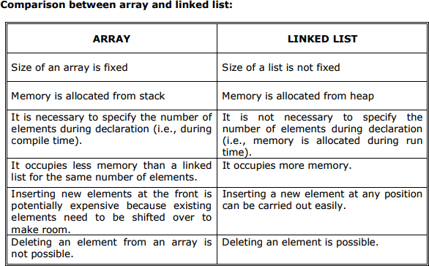

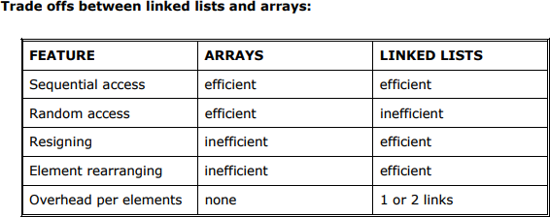

Applications of linked list:
- Linked lists are used to represent and manipulate polynomial. Polynomials are expression containing terms with non zero coefficient and exponents. For example: P(x) = a0 Xn + a1 Xn-1 + …… + an-1 X + an
- Represent very large numbers and operations of the large number such as addition, multiplication and division.
- Linked lists are to implement stack, queue, trees and graphs. 4. Implement the symbol table in compiler construction.

Single Linked List:
A linked list allocates space for each element separately in its own block of memory called a "node". The list gets an overall structure by using pointers to connect all its nodes together like the links in a chain. Each node contains two fields; a "data" field to store whatever element, and a "next" field which is a pointer used to link to the next node. Each node is allocated in the heap using malloc(), so the node memory continues to exist until it is explicitly de-allocated using free(). The front of the list is a pointer to the “start” node.
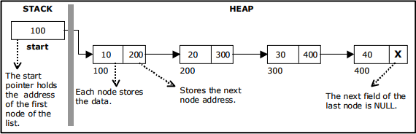
A single linked list
The beginning of the linked list is stored in a "start" pointer which points to the first node. The first node contains a pointer to the second node. The second node contains a pointer to the third node, ... and so on. The last node in the list has its next field set to NULL to mark the end of the list. Code can access any node in the list by starting at the start and following the next pointers.
The start pointer is an ordinary local pointer variable, so it is drawn separately on the left top to show that it is in the stack. The list nodes are drawn on the right to show that they are allocated in the heap.

The basic operations in a single linked list are:
- Creation.
- Insertion.
- Deletion.
- Traversing.

Creating a node for Single Linked List:
Creating a singly linked list starts with creating a node. Sufficient memory has to be allocated for creating a node. The information is stored in the memory.

Insertion of a Node:
One of the most primitive operations that can be done in a singly linked list is the insertion of a node. Memory is to be allocated for the new node (in a similar way that is done while creating a list) before reading the data. The new node will contain empty data field and empty next field. The data field of the new node is then stored with the information read from the user. The next field of the new node is assigned to NULL. The new node can then be inserted at three different places namely:
- Inserting a node at the beginning.
- Inserting a node at the end.
- Inserting a node at intermediate position.

Inserting a node at the beginning.
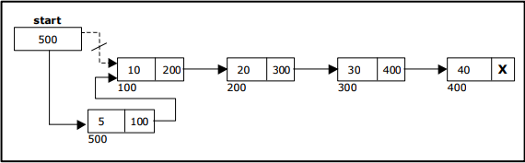

  - Inserting a node at the end:

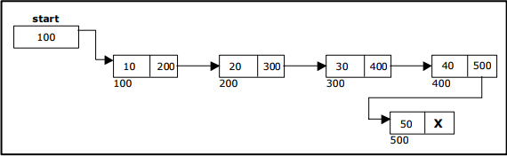

Inserting a node into the single linked list at a specified intermediate position other than beginning and end.

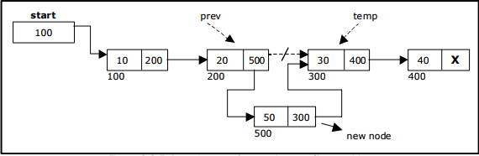

Deletion of a node:
Another primitive operation that can be done in a singly linked list is the deletion of a node. Memory is to be released for the node to be deleted. A node can be deleted from the list from three different places namely.
- Deleting a node at the beginning.
- Deleting a node at the end.
- Deleting a node at intermediate position.

Deleting a node at the beginning:
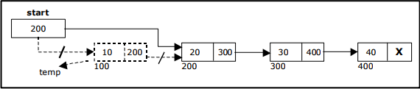

Deleting a node at the end:
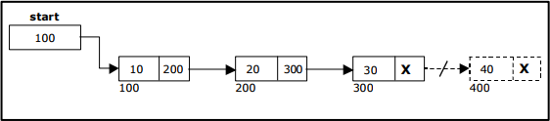

Deleting a node at Intermediate position:
The following steps are followed, to delete a node from an intermediate position in the list (List must contain more than two node).
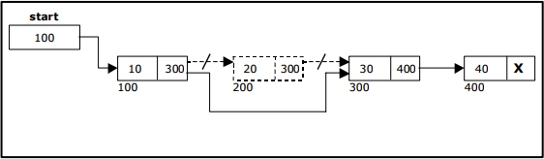
Traversal and displaying a list (Left to Right):
To display the information, you have to traverse (move) a linked list, node by node from the first node, until the end of the list is reached.

Traversing a list involves the following steps:
- Assign the address of start pointer to a temp pointer.
- Display the information from the data field of each node. The function traverse () is used for traversing and displaying the information stored in the list from left to right.

Source Code for creating and inserting the Implementation of Single Linked List:
class Item:
'''An Item that stores the data of a Linked List''' def init (self, data):
'''Initializes the data of the Item''' self._content = data # non-public data self.next = None

class SingleLikedList:
'''Single Linked List Implementation''' def init (self):
self._start = None

self._count = 0

def getItemAtIndex(self, pos): if self._start == None:
return None i = 0
cursor = self._start while cursor != None:
if i == pos: return cursor
i += 1
cursor = cursor.next return None
def insert(self, data, pos = 0): item = Item(data)

if self._start == None: self._start = item
else:
cursor = self.getItemAtIndex(pos) item.next = cursor.next
item.next = cursor.next cursor.next = item

self._count += 1
def display(self): cursor = self._start
while cursor != None: print(cursor._content, end=' ') cursor = cursor.next
l = SingleLikedList() l.insert(10) l.insert(20)

l.insert(30) l.insert(40) l.insert(50, 3) l.display()

Source Code for creating , inserting ,deleting the Implementation of Single Linked List:

class Node(object):
def init (self, data=None, next_node=None): self.data = data
self.next_node = next_node def get_data(self):
return self.data def get_next(self):
return self.next_node
def set_next(self, new_next): self.next_node = new_next

class LinkedList(object):
def init (self, head=None): self.head = head
def insert(self, data): new_node = Node(data)
new_node.set_next(self.head) self.head = new_node
def size(self): current = self.head count = 0
while current: count += 1
current = current.get_next() return count
def search(self, data): current = self.head found = False

while current and found is False: if current.get_data() == data:
found = True else:
current = current.get_next() if current is None:
raise ValueError("Data not in list") return current
def delete(self, data): current = self.head previous = None found = False
while current and found is False: if current.get_data() == data:
found = True else:
previous = current
current = current.get_next() if current is None:
raise ValueError("Data not in list") if previous is None:
self.head = current.get_next() else:
previous.set_next(current.get_next())

Source Code for creating , inserting ,deleting the Implementation of Single Linked List:
import sys import os.path
sys.path.append(os.path.join(os.path.abspath(os.pardir), "/home/satya/PycharmProjects/DataStractures")) from LinkedList2 import LinkedList
import unittest
class TestLinkedList(unittest.TestCase): def setUp(self):
self.list = LinkedList() def tearDown(self):

self.list = None def test_insert(self):
self.list.insert("David") self.assertTrue(self.list.head.get_data() == "David") self.assertTrue(self.list.head.get_next() is None)
def test_insert_two(self): self.list.insert("David") self.list.insert("Thomas")
self.assertTrue(self.list.head.get_data() == "Thomas") head_next = self.list.head.get_next() self.assertTrue(head_next.get_data() == "David")
def test_nextNode(self): self.list.insert("Jacob") self.list.insert("Pallymay") self.list.insert("Rasmus")
self.assertTrue(self.list.head.get_data() == "Rasmus") head_next = self.list.head.get_next() self.assertTrue(head_next.get_data() == "Pallymay") last = head_next.get_next() self.assertTrue(last.get_data() == "Jacob")
def test_positive_search(self): self.list.insert("Jacob") self.list.insert("Pallymay") self.list.insert("Rasmus")
found = self.list.search("Jacob") self.assertTrue(found.get_data() == "Jacob") found = self.list.search("Pallymay") self.assertTrue(found.get_data() == "Pallymay") found = self.list.search("Jacob") self.assertTrue(found.get_data() == "Jacob")
def test_searchNone(self): self.list.insert("Jacob") self.list.insert("Pallymay")
# make sure reg search works found = self.list.search("Jacob")

self.assertTrue(found.get_data() == "Jacob") with self.assertRaises(ValueError):
self.list.search("Vincent") def test_delete(self):
self.list.insert("Jacob") self.list.insert("Pallymay") self.list.insert("Rasmus") # Delete the list head self.list.delete("Rasmus")
self.assertTrue(self.list.head.get_data() == "Pallymay") # Delete the list tail
self.list.delete("Jacob") self.assertTrue(self.list.head.get_next() is None)
def test_delete_value_not_in_list(self): self.list.insert("Jacob") self.list.insert("Pallymay") self.list.insert("Rasmus")
with self.assertRaises(ValueError): self.list.delete("Sunny")
def test_delete_empty_list(self):
with self.assertRaises(ValueError): self.list.delete("Sunny")
def test_delete_next_reassignment(self): self.list.insert("Jacob") self.list.insert("Cid") self.list.insert("Pallymay") self.list.insert("Rasmus") self.list.delete("Pallymay") self.list.delete("Cid")
self.assertTrue(self.list.head.next_node.get_data() == "Jacob")

Source Code for creating , inserting ,deleting the Implementation of Single Linked List:

class Node(object):
def init (self, data, next): self.data = data

self.next = next
class SingleList(object): head = None
tail = None
def show(self):
print "Showing list data:" current_node = self.head
while current_node is not None: print current_node.data, " -> ", current_node = current_node.next
print None
def append(self, data):
node = Node(data, None)
if self.head is None: self.head = self.tail = node

else:
self.tail.next = node self.tail = node
def remove(self, node_value): current_node = self.head previous_node = None
while current_node is not None:
if current_node.data == node_value:
# if this is the first node (head)
if previous_node is not None: previous_node.next = current_node.next

else:
self.head = current_node.next

# needed for the next iteration previous_node = current_node current_node = current_node.next
s = SingleList() s.append(31) s.append(2)

s.append(3) s.append(4) s.show() s.remove(31) s.remove(3) s.remove(2) s.show()

Using a header node:
A header node is a special dummy node found at the front of the list. The use of header node is an alternative to remove the first node in a list. For example, the picture below shows how the list with data 10, 20 and 30 would be represented using a linked list without and with a header node:
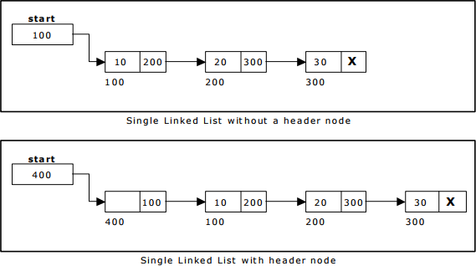
Note that if your linked lists do include a header node, there is no need for the special case code given above for the remove operation; node n can never be the first node in the list, so there is no need to check for that case. Similarly, having a header node can simplify the code that adds a node before a given node n.
Note that if you do decide to use a header node, you must remember to initialize an empty list to contain one (dummy) node, you must remember not to include the header node in the count of "real" nodes in the list.
It is also useful when information other than that found in each node of the list is needed. For example, imagine an application in which the number of items in a list is often calculated. In a standard linked list, the list function to count the number of nodes has to traverse the entire list every time. However, if the current length is maintained in a header node, that information can be obtained very quickly. 3.5. Array based linked lists: Another alternative is to allocate the nodes in blocks. In fact, if you know the

maximum size of a list a head of time, you can pre-allocate the nodes in a single array. The result is a hybrid structure – an array based linked list.
shows an example of null terminated single linked list where all the nodes are allocated contiguously in an array.
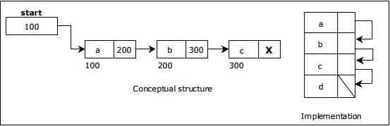

Double Linked List: A double linked list is a two-way list in which all nodes will have two links. This helps in accessing both successor node and predecessor node from the given node position. It provides bi- directional traversing. Each node contains three fields:
- Left link.
- Data.
- Right link.
The left link points to the predecessor node and the right link points to the successor node. The data field stores the required data.
Many applications require searching forward and backward thru nodes of a list. For example searching for a name in a telephone directory would need forward and backward scanning thru a region of the whole list.

The basic operations in a double linked list are:
- Creation.
- Insertion.
- Deletion.
- Traversing.

A double linked list is shown in figure

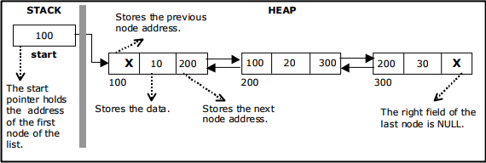

The beginning of the double linked list is stored in a "start" pointer which points to the first node. The first node‟s left link and last node‟s right link is set to NULL.

Creating a node for Double Linked List:
Creating a double linked list starts with creating a node. Sufficient memory has to be allocated for creating a node. The information is stored in the memory.
Double Linked List with 3 nodes:
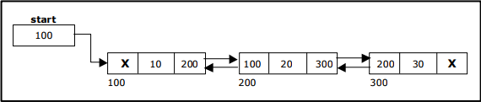

Inserting a node at the beginning:
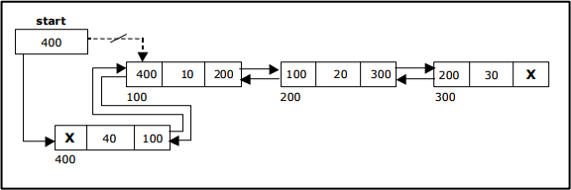

Inserting a node at the end:

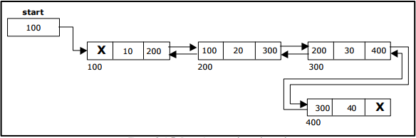

Inserting a node at an intermediate position:
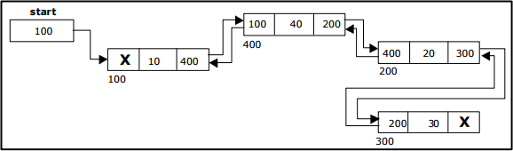
Deleting a node at the beginning:
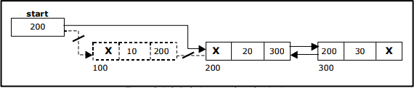

Deleting a node at the end:
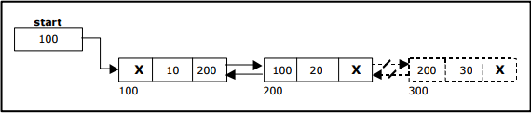

Deleting a node at Intermediate position:

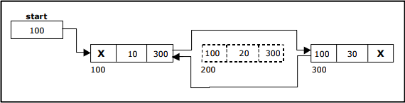

Traversal and displaying a list (Left to Right):
To display the information, you have to traverse the list, node by node from the first node, until the end of the list is reached. The function traverse_left_right() is used for traversing and displaying the information stored in the list from left to right.

Traversal and displaying a list (Right to Left):
To display the information from right to left, you have to traverse the list, node by node from the first node, until the end of the list is reached. The function traverse_right_left() is used for traversing and displaying the information stored in the list from right to left.

1.Source Code for the Implementation of Double Linked List:
class DList:
def init (self): self.head = None self.size = 0
def insert(self, data): self.size += 1
if self.head is None: self.head = Node(data)
else:
p = Node(data) p.next = self.head
self.head.previous = p self.head = p
def remove(self, index): if self.head is None:
raise ValueError('Removing off an empty list') if index < 0 or index >= self.size:
raise IndexError("Index is either negative or greater than the list size.")

current = self.head if index == 0:
self.head = self.head.next self.head.previous = None
else:
for _ in range(index -1): current = current.next
p = current.next.next if p is None:
current.next = None else:
current.next = p p.previous = current
def sizeof (self): return self.size
def repr (self): res = '[ '
current = self.head
while current is not None: res += str(current.data) res += ' '
current = current.next res += ']'
return res class Node:
def init (self, data): if data is None:
raise ValueError('Node value cannot be None') self.data = data
self.previous = None self.next = None

Source Code for the Implementation of Double Linked List: class Node(object):
def init (self, data, prev, next):

self.data = data self.prev = prev self.next = next

class DoubleList(object): head = None
tail = None
def append(self, data):
new_node = Node(data, None, None)
if self.head is None:
self.head = self.tail = new_node

else:
new_node.prev = self.tail new_node.next = None self.tail.next = new_node self.tail = new_node
def remove(self, node_value):
current_node = self.head

while current_node is not None:
if current_node.data == node_value:
# if it's not the first element
if current_node.prev is not None: current_node.prev.next = current_node.next current_node.next.prev = current_node.prev

else:
# otherwise we have no prev (it's None), head is the next one, and prev becomes None
self.head = current_node.next current_node.next.prev = None

current_node = current_node.next

def show(self):
print "Show list data:" current_node = self.head

while current_node is not None:
print current_node.prev.data if hasattr(current_node.prev, "data") else None,
print current_node.data,
print current_node.next.data if hasattr(current_node.next, "data") else None

current_node = current_node.next
print "*"*50 d = DoubleList() d.append(5) d.append(6) d.append(50) d.append(30) d.show() d.remove(50) d.remove(5) d.show()

Circular Single Linked List:
It is just a single linked list in which the link field of the last node points back to the address of the first node. A circular linked list has no beginning and no end. It is necessary to establish a special pointer called start pointer always pointing to the first node of the list. Circular linked lists are frequently used instead of ordinary linked list because many operations are much easier to implement. In circular linked list no null pointers are used, hence all pointers contain valid address.
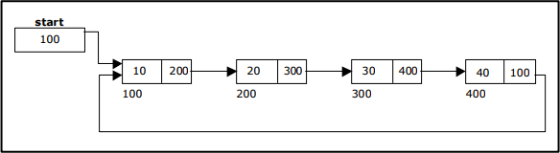
Creating a circular single Linked List with „n‟ number of nodes:

The basic operations in a circular single linked list are:
- Creation.
- Insertion.
- Deletion.
- Traversing.

Inserting a node at the beginning:
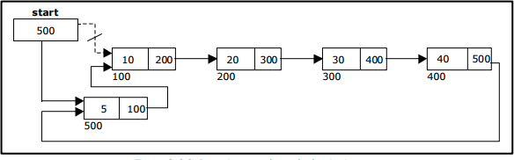
Inserting a node at the end:
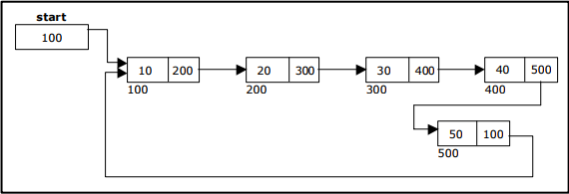

Deleting a node at the beginning:
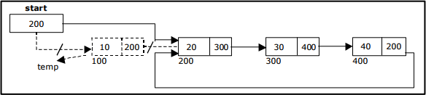

Deleting a node at the end:
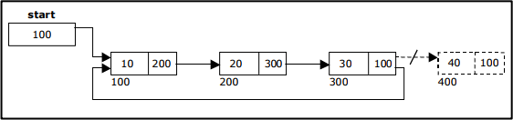

Source Code for Circular Single Linked List:

from enum import Enum class NodeConstants(Enum):
FRONT_NODE = 1
class Node:
def init (self, element=None, next_node=None): self.element = element
self.next_node = next_node def str (self):
if self.element:
return self.element. str () else:
return 'Empty Node' def repr (self):
return self. str () class CircularLinkedList:
def init (self):
self.head = Node(element=NodeConstants.FRONT_NODE) self.head.next_node = self.head
def size(self):
count = 0
current = self.head.next_node while current != self.head:
count += 1
current = current.next_node return count
def insert_front(self, data):
node = Node(element=data, next_node=self.head.next_node) self.head.next_node = node
def insert_last(self, data):
current_node = self.head.next_node
while current_node.next_node != self.head: current_node = current_node.next_node
node = Node(element=data, next_node=current_node.next_node) current_node.next_node = node
def insert(self, data, position):

if position == 0: self.insert_front(data)
elif position == self.size(): self.insert_last(data)
else:
if 0 < position < self.size(): current_node = self.head.next_node current_pos = 0
while current_pos < position - 1:
current_pos += 1
current_node = current_node.next_node node = Node(data, current_node.next_node) current_node.next_node = node
else:
raise IndexError def remove_first(self):
self.head.next_node = self.head.next_node.next_node def remove_last(self):
current_node = self.head.next_node
while current_node.next_node.next_node != self.head: current_node = current_node.next_node
current_node.next_node = self.head def remove(self, position):
if position == 0: self.remove_first()
elif position == self.size(): self.remove_last()
else:
if 0 < position < self.size(): current_node = self.head.next_node current_pos = 0
while current_pos < position - 1:
current_node = current_node.next_node current_pos += 1
current_node.next_node = current_node.next_node.next_node

else:
raise IndexError def fetch(self, position):
if 0 <= position < self.size(): current_node = self.head.next_node current_pos = 0
while current_pos < position:
current_node = current_node.next_node current_pos += 1
return current_node.element else:
raise IndexError import unittest
from random import randint
class TestCircularLinkedList(unittest.TestCase): names = ['Bob Belcher',
'Linda Belcher', 'Tina Belcher', 'Gene Belcher', 'Louise Belcher']
def test_init(self):
dll = CircularLinkedList() self.assertIsNotNone(dll.head) self.assertEqual(dll.size(), 0)
def test_insert_front(self):
dll = CircularLinkedList()
for name in TestCircularLinkedList.names: dll.insert_front(name)
self.assertEqual(dll.fetch(0), TestCircularLinkedList.names[4]) self.assertEqual(dll.fetch(1), TestCircularLinkedList.names[3]) self.assertEqual(dll.fetch(2), TestCircularLinkedList.names[2]) self.assertEqual(dll.fetch(3), TestCircularLinkedList.names[1]) self.assertEqual(dll.fetch(4), TestCircularLinkedList.names[0])

def test_insert_last(self):

dll = CircularLinkedList()
for name in TestCircularLinkedList.names: dll.insert_last(name)
for i in range(len(TestCircularLinkedList.names) - 1): self.assertEqual(dll.fetch(i), TestCircularLinkedList.names[i])
def test_insert(self):
dll = CircularLinkedList()
for name in TestCircularLinkedList.names: dll.insert_last(name)
pos = randint(0, len(TestCircularLinkedList.names) - 1) dll.insert('Teddy', pos)
self.assertEqual(dll.fetch(pos), 'Teddy') def test_remove_first(self):
dll = CircularLinkedList()
for name in TestCircularLinkedList.names: dll.insert_last(name)
for i in range(dll.size(), 0, -1): self.assertEqual(dll.size(), i) dll.remove_first()
def test_remove_last(self):
dll = CircularLinkedList()
for name in TestCircularLinkedList.names: dll.insert_last(name)
for i in range(dll.size(), 0, -1): self.assertEqual(dll.size(), i) dll.remove_last()
def test_remove(self):
dll = CircularLinkedList()
for name in TestCircularLinkedList.names: dll.insert_last(name)
dll.remove(1)
self.assertEqual(dll.fetch(0), 'Bob Belcher') self.assertEqual(dll.fetch(1), 'Tina Belcher') self.assertEqual(dll.fetch(2), 'Gene Belcher') self.assertEqual(dll.fetch(3), 'Louise Belcher')

if name == ' main ':
unittest.main()

Circular Double Linked List:
A circular double linked list has both successor pointer and predecessor pointer in circular manner. The objective behind considering circular double linked list is to simplify the insertion and deletion operations performed on double linked list. In circular double linked list the right link of the right most node points back to the start node and left link of the first node points to the last node.
A circular double linked list is shown in figure
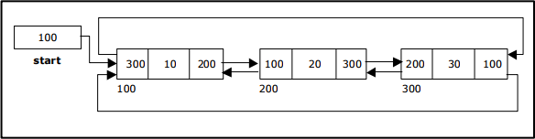
Creating a Circular Double Linked List with „n‟ number of nodes

The basic operations in a circular double linked list are:
- Creation.
- Insertion.
- Deletion.
- Traversing.

Inserting a node at the beginning:
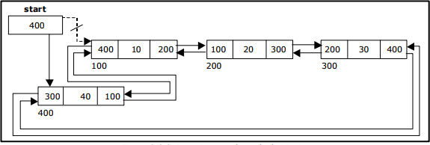
Inserting a node at the end:

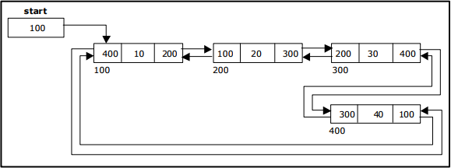

Inserting a node at an intermediate position:
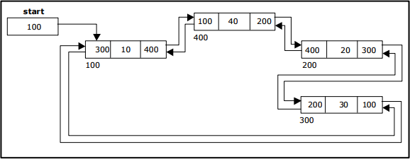
Deleting a node at the beginning:
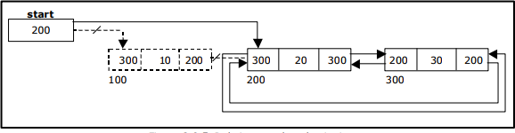

Deleting a node at the end:

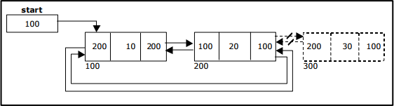

Deleting a node at Intermediate position:
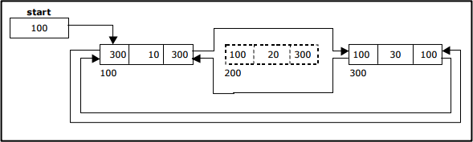

Comparison of Linked List Variations:
The major disadvantage of doubly linked lists (over singly linked lists) is that they require more space (every node has two pointer fields instead of one). Also, the code to manipulate doubly linked lists needs to maintain the prev fields as well as the next fields; the more fields that have to be maintained, the more chance there is for errors.
The major advantage of doubly linked lists is that they make some operations (like the removal of a given node, or a right-to-left traversal of the list) more efficient.
The major advantage of circular lists (over non-circular lists) is that they eliminate some extra-case code for some operations (like deleting last node). Also, some applications lead naturally to circular list representations. For example, a computer network might best be modeled using a circular list.

Stacks ADT Operations:
A stack is a container of objects that are inserted and removed according to the last-in first-out (LIFO) principle. In the pushdown stacks only two operations are allowed: push the item into the stack, and pop the item out of the stack. A stack is a limited access data structure - elements can be added and removed from the stack only at the top. Push adds an item to the top of the stack, pop removes the item from the top. A helpful analogy is to think of a stack of books; you can remove only the top book, also you can add a new book on the top.
A stack may be implemented to have a bounded capacity. If the stack is full and does not contain enough space to accept an entity to be pushed, the stack is then considered to be in an overflow state. The pop operation removes an item from the top of the stack. A pop either reveals previously concealed items or results in an empty stack, but, if the stack is empty, it goes into underflow state, which means no items are present in stack to be removed.
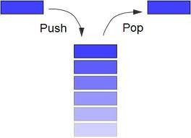

Stack (ADT) Data Structure:
Stack is an Abstract data structure (ADT) works on the principle Last In First Out (LIFO). The last element add to the stack is the first element to be delete. Insertion and deletion can be takes place at one end called TOP. It looks like one side closed tube.
- The add operation of the stack is called push operation
- The delete operation is called as pop operation.
- Push operation on a full stack causes stack overflow.
- Pop operation on an empty stack causes stack underflow.
- SP is a pointer, which is used to access the top element of the stack.
- If you push elements that are added at the top of the stack;
- In the same way when we pop the elements, the element at the top of the stack is deleted.

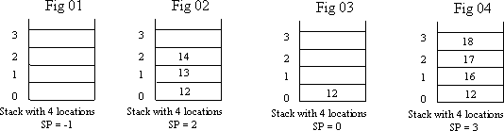

Operations of stack:
There are two operations applied on stack they are
- push
- pop.
While performing push & pop operations the following test must be conducted on the stack.
- Stack is empty or not
- Stack is full or not
Push:
Push operation is used to add new elements in to the stack. At the time of addition first check the stack is full or not. If the stack is full it generates an error message "stack overflow".
Pop:
Pop operation is used to delete elements from the stack. At the time of deletion first check the stack is empty or not. If the stack is empty it generates an error message "stack underflow".

Representation of a Stack using Arrays:
Let us consider a stack with 6 elements capacity. This is called as the size of the stack. The number of elements to be added should not exceed the maximum size of the stack. If we attempt to add new element beyond the maximum size, we will encounter a stack overflow condition. Similarly, you cannot remove elements beyond the base of the stack. If such is the case, we will reach a stack underflow condition.
When a element is added to a stack, the operation is performed by push().
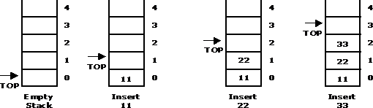

When an element is taken off from the stack, the operation is performed by pop().

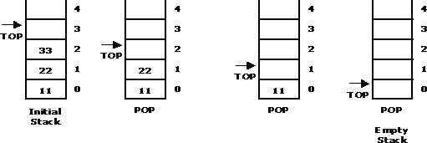

Source code for stack operations, using array:
STACK: Stack is a linear data structure which works under the principle of last in first out. Basic operations: push, pop, display.
  - PUSH: if (top==MAX), display Stack overflow else reading the data and making stack [top]
=data and incrementing the top value by doing top++.
  - POP: if (top==0), display Stack underflow else printing the element at the top of the stack and decrementing the top value by doing the top.
  - DISPLAY: IF (TOP==0), display Stack is empty else printing the elements in the stack from stack [0] to stack [top].
# Python program for implementation of stack

# import maxsize from sys module
# Used to return -infinite when stack is empty from sys import maxsize

# Function to create a stack. It initializes size of stack as 0 def createStack():
stack = [] return stack

# Stack is empty when stack size is 0 def isEmpty(stack):
return len(stack) == 0

# Function to add an item to stack. It increases size by 1 def push(stack, item):
stack.append(item) print("pushed to stack " + item)

# Function to remove an item from stack. It decreases size by 1 def pop(stack):
if (isEmpty(stack)): print("stack empty")

return str(-maxsize -1) #return minus infinite return stack.pop()
# Driver program to test above functions stack = createStack()
print("maximum size of array is",maxsize) push(stack, str(10))
push(stack, str(20)) push(stack, str(30))
print(pop(stack) + " popped from stack") print(pop(stack) + " popped from stack") print(pop(stack) + " popped from stack") print(pop(stack) + " popped from stack") push(stack, str(10))
push(stack, str(20)) push(stack, str(30))
print(pop(stack) + " popped from stack")

Linked List Implementation of Stack:
We can represent a stack as a linked list. In a stack push and pop operations are performed at one end called top. We can perform similar operations at one end of list using top pointer.
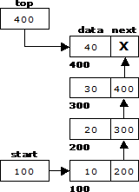

Source code for stack operations, using linked list:
# Python program for linked list implementation of stack

# Class to represent a node class StackNode:

# Constructor to initialize a node def init (self, data):
self.data = data

self.next = None class Stack:
# Constructor to initialize the root of linked list def init (self):
self.root = None

def isEmpty(self):
return True if self.root is None else False

def push(self, data):
newNode = StackNode(data) newNode.next = self.root self.root = newNode
print ("%d pushed to stack" %(data))

def pop(self):
if (self.isEmpty()): return float("-inf")
temp = self.root self.root = self.root.next popped = temp.data return popped

def peek(self):
if self.isEmpty(): return float("-inf")
return self.root.data

# Driver program to test above class stack = Stack()
stack.push(10) stack.push(20) stack.push(30)

print ("%d popped from stack" %(stack.pop())) print ("Top element is %d " %(stack.peek())) Stack Applications:
- Stack is used by compilers to check for balancing of parentheses, brackets and braces.
- Stack is used to evaluate a postfix expression.
- Stack is used to convert an infix expression into postfix/prefix form.

- In recursion, all intermediate arguments and return values are stored on the processor‟s stack.
- During a function call the return address and arguments are pushed onto a stack and on return they are popped off.
- Depth first search uses a stack data structure to find an element from a graph.

In-fix- to Postfix Transformation:
Procedure:
Procedure to convert from infix expression to postfix expression is as follows:
- Scan the infix expression from left to right.
- a) If the scanned symbol is left parenthesis, push it onto the stack.
  - If the scanned symbol is an operand, then place directly in the postfix expression (output).
  - If the symbol scanned is a right parenthesis, then go on popping all the items from the stack and place them in the postfix expression till we get the matching left parenthesis.
  - If the scanned symbol is an operator, then go on removing all the operators from the stack and place them in the postfix expression, if and only if the precedence of the operator which is on the top of the stack is greater than (or equal) to the precedence of the scanned operator and push the scanned operator onto the stack otherwise, push the scanned operator onto the stack.
Convert the following infix expression A + B * C – D / E * H into its equivalent postfix expression.

Symbol | Postfix string | Stack | Remarks
A | A
+ | A | +
B | A B | +
* | A B | + *
C | A B C | -
- | A B C * + | -
D | A B C * + D | -
/ | A B C * + D | - /
E | A B C * + D E | - /
* | A B C * + D E / | - *

H | A B C * + D E / H | - *
End of string | A B C * + D E / H * - | The input is now empty. Pop the output symbols from the stack until it is empty.

Source Code:
# Python program to convert infix expression to postfix

# Class to convert the expression import string
class Conversion:

# Constructor to initialize the class variables def init (self, capacity):
self.top = -1 self.capacity = capacity
# This array is used a stack self.array = []
# Precedence setting self.output = []
self.precedence = {'+':1, '-':1, '*':2, '/':2, '^':3}

# check if the stack is empty def isEmpty(self):
return True if self.top == -1 else False

# Return the value of the top of the stack def peek(self):
return self.array[-1]

# Pop the element from the stack def pop(self):
if not self.isEmpty(): self.top -= 1
return self.array.pop() else:
return "$"

# Push the element to the stack def push(self, op):
self.top += 1 self.array.append(op)

# A utility function to check is the given character # is operand
def isOperand(self, ch): return ch.isalpha()

# Check if the precedence of operator is strictly # less than top of stack or not

def notGreater(self, i): try:
a = self.precedence[i]
b = self.precedence[self.peek()] return True if a <= b else False
except KeyError: return False

# The main function that converts given infix expression # to postfix expression
def infixToPostfix(self, exp):

# Iterate over the expression for conversion for i in exp:
# If the character is an operand, # add it to output
if self.isOperand(i): self.output.append(i)

# If the character is an '(', push it to stack elif i == '(':
self.push(i)

# If the scanned character is an ')', pop and # output from the stack until and '(' is found elif i == ')':
while( (not self.isEmpty()) and self.peek() != '('): a = self.pop()
self.output.append(a)
if (not self.isEmpty() and self.peek() != '('): return -1
else:
self.pop()

# An operator is encountered else:
while(not self.isEmpty() and self.notGreater(i)): self.output.append(self.pop())
self.push(i)

# pop all the operator from the stack while not self.isEmpty():
self.output.append(self.pop())

result= "".join(self.output) print(result)
# Driver program to test above function exp = "a+b*(c^d-e)^(f+g*h)-i"
obj = Conversion(len(exp)) obj.infixToPostfix(exp)

Evaluating Arithmetic Expressions:
Procedure:
The postfix expression is evaluated easily by the use of a stack. When a number is seen, it is pushed onto the stack; when an operator is seen, the operator is applied to the two numbers that are popped from the stack and the result is pushed onto the stack.
Evaluate the postfix expression: 6 5 2 3 + 8 * + 3 + *

Symbol | Operand 1 | Operand 2 | Value | Stack | Remarks
6 |  |  |  | 6
5 |  |  |  | 6, 5
2 |  |  |  | 6, 5, 2
3 |  |  |  | 6, 5, 2, 3 | The first four symbols are placed on the stack.
+ | 2 | 3 | 5 | 6, 5, 5 | Next a „+‟ is read, so 3 and 2 are popped from the stack and their sum 5, is pushed
8 | 2 | 3 | 5 | 6, 5, 5, 8 | Next 8 is pushed
* | 5 | 8 | 40 | 6, 5, 40 | Now a „*‟ is seen, so 8 and 5 are popped as 8 * 5 = 40 is pushed
+ | 5 | 40 | 45 | 6, 45 | Next, a „+‟ is seen, so 40 and 5 are popped and 40 + 5 = 45 is pushed
3 | 5 | 40 | 45 | 6, 45, 3 | Now, 3 is pushed
+ | 45 | 3 | 48 | 6, 48 | Next, „+‟ pops 3 and 45 and pushes 45 + 3 = 48 is pushed
* | 6 | 48 | 288 | 288 | Finally, a „*‟ is seen and 48 and 6 are popped, the result 6  * 48 = 288 is pushed

Source Code:
# Python program to evaluate value of a postfix expression

# Class to convert the expression class Evaluate:

# Constructor to initialize the class variables def init (self, capacity):
self.top = -1

self.capacity = capacity
# This array is used a stack self.array = []

# check if the stack is empty def isEmpty(self):
return True if self.top == -1 else False

# Return the value of the top of the stack def peek(self):
return self.array[-1]

# Pop the element from the stack def pop(self):
if not self.isEmpty(): self.top -= 1
return self.array.pop() else:
return "$"

# Push the element to the stack def push(self, op):
self.top += 1 self.array.append(op)

# The main function that converts given infix expression # to postfix expression
def evaluatePostfix(self, exp):

# Iterate over the expression for conversion for i in exp:

# If the scanned character is an operand # (number here) push it to the stack
if i.isdigit(): self.push(i)

# If the scanned character is an operator,
# pop two elements from stack and apply it. else:
val1 = self.pop() val2 = self.pop()
self.push(str(eval(val2 + i + val1))) return int(self.pop())
# Driver program to test above function exp = "231*+9-"
obj = Evaluate(len(exp))
print ("Value of {0} is {1}".format(exp, obj.evaluatePostfix(exp)))

Basic Queue Operations:
A queue is a data structure that is best described as "first in, first out". A queue is another special kind of list, where items are inserted at one end called the rear and deleted at the other end called the front. A real world example of a queue is people waiting in line at the bank. As each person enters the bank, he or she is "enqueued" at the back of the line. When a teller becomes available, they are "dequeued" at the front of the line.

Representation of a Queue using Array:
Let us consider a queue, which can hold maximum of five elements. Initially the queue is empty.

0 1 2 3 4

Q u e u e E mp t y
F RO NT = RE A R = 0

F R

Now, insert 11 to the queue. Then queue status will be:

0 1 2 3 4
11

F R

RE A R = RE A R + 1 = 1 F RO NT = 0

Next, insert 22 to the queue. Then the queue status is:

0 1 2 3 4
11 | 22

F R

RE A R = RE A R + 1 = 2 F RO NT = 0

Again insert another element 33 to the queue. The status of the queue is:

0 1 2 3 4
11 | 22 | 33

F R

RE A R = RE A R + 1 = 3 F RO NT = 0

Now, delete an element. The element deleted is the element at the front of the queue. So the status of the queue is:

0 1 2 3 4
 | 22 | 33

F R

RE A R = 3
F RO NT = F R O NT + 1 = 1

Again, delete an element. The element to be deleted is always pointed to by the FRONT pointer. So, 22 is deleted. The queue status is as follows:

0 1 2 3 4
33

F R

RE A R = 3
F RO NT = F R O NT + 1 = 2

Now, insert new elements 44 and 55 into the queue. The queue status is:

0 1 2 3 4
 |  | 33 | 44 | 55

F R

RE A R = 5 F RO NT = 2

Next insert another element, say 66 to the queue. We cannot insert 66 to the queue as the rear crossed the maximum size of the queue (i.e., 5). There will be queue full signal. The queue status is as follows:

0 1 2 3 4
 |  | 33 | 44 | 55

F R

RE A R = 5 F RO NT = 2

Now it is not possible to insert an element 66 even though there are two vacant positions in the linear queue. To over come this problem the elements of the queue are to be shifted towards the beginning of the queue so that it creates vacant position at the rear end. Then the FRONT and REAR are to be adjusted properly. The element 66 can be inserted at the rear end. After this operation, the queue status is as follows:

0 1 2 3 4
33 | 44 | 55 | 66

RE A R = 4 F RO NT = 0

F R

This difficulty can overcome if we treat queue position with index 0 as a position that comes after position with index 4 i.e., we treat the queue as a circular queue.

Procedure for Queue operations using array:
In order to create a queue we require a one dimensional array Q(1:n) and two variables front and rear. The conventions we shall adopt for these two variables are that front is always 1 less than the actual front of the queue and rear always points to the last element in the queue. Thus, front = rear if and only if there are no elements in the queue. The initial condition then is front = rear = 0.
The various queue operations to perform creation, deletion and display the elements in a queue are as follows:
- insertQ(): inserts an element at the end of queue Q.
- deleteQ(): deletes the first element of Q.
- displayQ(): displays the elements in the queue.
Linked List Implementation of Queue: We can represent a queue as a linked list. In a queue data is deleted from the front end and inserted at the rear end. We can perform similar operations on the two ends of a list. We use two pointers front and rear for our linked queue implementation.
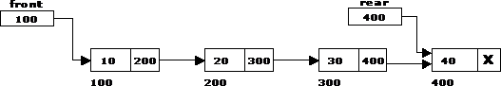

Source Code:
front = 0
rear = 0
mymax = 3
# Function to create a stack. It initializes size of stack as 0 def createQueue():
queue = [] return queue
# Stack is empty when stack size is 0 def isEmpty(queue):
return len(queue) == 0
# Function to add an item to stack. It increases size by 1 def enqueue(queue,item):
queue.append(item)
# Function to remove an item from stack. It decreases size by 1 def dequeue(queue):
if (isEmpty(queue)): return "Queue is empty"
item=queue[0] del queue[0] return item
# Driver program to test above functions queue = createQueue()
while True:
print("1 Enqueue") print("2 Dequeue") print("3 Display") print("4 Quit")

ch=int(input("Enter choice")) if(ch==1):
if(rear < mymax): item=input("enter item") enqueue(queue, item) rear = rear + 1
else:
print("Queue is full") elif(ch==2):
print(dequeue(queue)) elif(ch==3):
print(queue) else:
break

Applications of Queues:
- It is used to schedule the jobs to be processed by the CPU.
- When multiple users send print jobs to a printer, each printing job is kept in the printing queue. Then the printer prints those jobs according to first in first out (FIFO) basis.
- Breadth first search uses a queue data structure to find an element from a graph.

Disadvantages of Linear Queue:
There are two problems associated with linear queue. They are:
- Time consuming: linear time to be spent in shifting the elements to the beginning of the queue.
- Signaling queue full: even if the queue is having vacant position.

Round Robin Algorithm:
The round-robin (RR) scheduling algorithm is designed especially for time-sharing systems. It is similar to FCFS scheduling, but pre-emption is added to switch between processes. A small unit of time, called a time quantum or time slices, is defined. A time quantum is generally from 10 to 100 milliseconds. The ready queue is treated as a circular queue. To implement RR scheduling
- We keep the ready queue as a FIFO queue of processes.
- New processes are added to the tail of the ready queue.

- The CPU scheduler picks the first process from the ready queue, sets a timer to interrupt after 1 time quantum, and dispatches the process.
- The process may have a CPU burst of less than 1 time quantum.
  - In this case, the process itself will release the CPU voluntarily.
  - The scheduler will then proceed to the next process in the ready queue.
- Otherwise, if the CPU burst of the currently running process is longer than 1 time quantum,
  - The timer will go off and will cause an interrupt to the OS.
  - A context switch will be executed, and the process will be put at the tail of the ready queue.
  - The CPU scheduler will then select the next process in the ready queue.
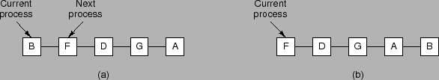
The average waiting time under the RR policy is often long. Consider the following set of processes that arrive at time 0, with the length of the CPU burst given in milliseconds: (a time quantum of 4 milliseconds)

 | Burst | Waiting | Turnaround
Process | Time | Time | Time
 | 24 | 6 | 30
 | 3 | 4 | 7
 | 3 | 7 | 10
Average | - | 5.66 | 15.66
Using round-robin scheduling, we would schedule these processes according to the following chart:
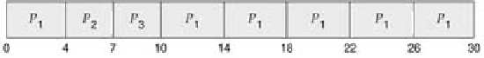

DEQUE(Double Ended Queue):
A double-ended queue (dequeue, often abbreviated to deque, pronounced deck) generalizes a queue, for which elements can be added to or removed from either the front (head) or back (tail).It is also often called a head-tail linked list. Like an ordinary queue, a double-ended queue is a data structure it supports the following operations: enq_front, enq_back, deq_front, deq_back, and empty. Dequeue can be behave like a queue by using only enq_front and deq_front , and behaves like a stack by using only enq_front and deq_rear.
The DeQueue is represented as follows.
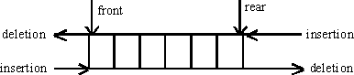

DEQUE can be represented in two ways they are
  - Input restricted DEQUE(IRD)
  - output restricted DEQUE(ORD)
The output restricted DEQUE allows deletions from only one end and input restricted DEQUE allow insertions at only one end. The DEQUE can be constructed in two ways they are
- Using array 2)Using linked list

Operations in DEQUE
  - Insert element at back
  - Insert element at front
  - Remove element at front
  - Remove element at back

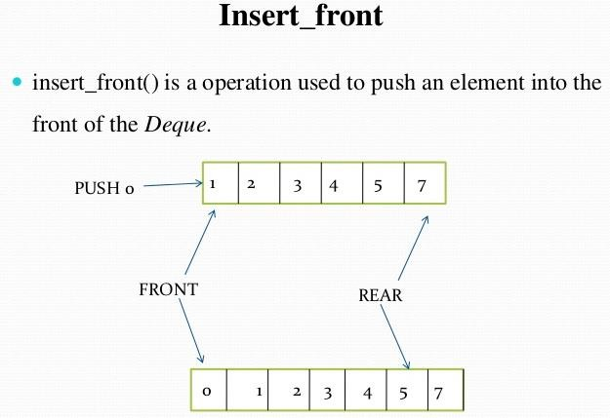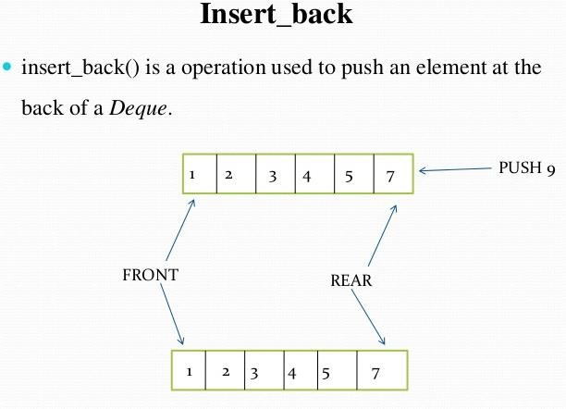
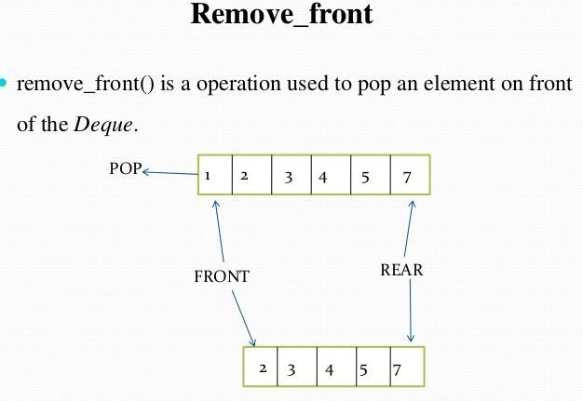

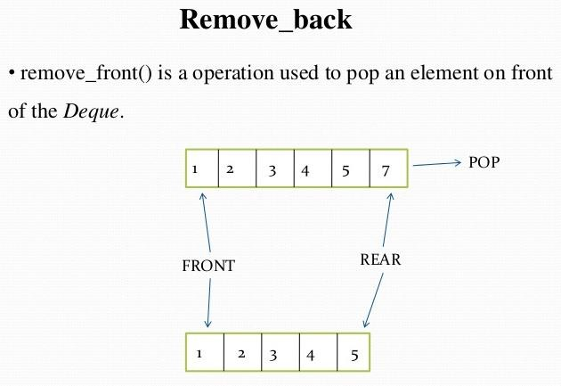

Applications of DEQUE:
- The A-Steal algorithm implements task scheduling for several processors (multiprocessor scheduling).
- The processor gets the first element from the deque.
- When one of the processor completes execution of its own threads it can steal a thread from another processor.
- It gets the last element from the deque of another processor and executes it.

Circular Queue:
Circular queue is a linear data structure. It follows FIFO principle. In circular queue the last node is connected back to the first node to make a circle.
- Circular linked list fallow the First In First Out principle
- Elements are added at the rear end and the elements are deleted at front end of the queue
- Both the front and the rear pointers points to the beginning of the array.
- It is also called as “Ring buffer”.
- Items can inserted and deleted from a queue in O(1) time. Circular Queue can be created in three ways they are
- Using single linked list
- Using double linked list
- Using arrays

Representation of Circular Queue:
Let us consider a circular queue, which can hold maximum (MAX) of six elements. Initially the queue is empty.

F R

1 Q u e u e E mp t y
5
0
3
2
4 M A X = 6
F RO NT = RE A R = 0 C O U NT = 0

C irc u lar Q u e u e

Now, insert 11 to the circular queue. Then circular queue status will be:

F

R
5
0
11
1
3
2

F RO NT = 0
4 RE A R = ( RE A R + 1) % 6 = 1
C O U NT = 1

C irc u lar Q u e u e

Insert new elements 22, 33, 44 and 55 into the circular queue. The circular queue status is:

1 F RO NT = 0, RE A R = 5
F
R

5
0
11
55
22
44
33
3
2
4 RE A R = RE A R % 6 = 5
C O U NT = 5

C irc u lar Q u e u e

Now, delete an element. The element deleted is the element at the front of the circular queue. So, 11 is deleted. The circular queue status is as follows:

R

F
5
0
55
22 1
44
33
3
2

F RO NT = (F R O NT + 1) % 6 = 1
4 RE A R = 5
C O U NT = C O U NT - 1 = 4

C irc u lar Q u e u e

Again, delete an element. The element to be deleted is always pointed to by the FRONT pointer. So, 22 is deleted. The circular queue status is as follows:

R

F RO NT = (F R O NT + 1) % 6 = 2
5
0
55
1
44
33
3
2
4 RE A R = 5
C O U NT = C O U NT - 1 = 3

F

C irc u lar Q u e u e

Again, insert another element 66 to the circular queue. The status of the circular queue is:

R

4 F RO NT = 2
5
0
66
55
1
44
33
3
2
RE A R = ( RE A R + 1) % 6 = 0 C O U NT = C O U NT + 1 = 4

F

C irc u lar Q u e u e

Now, insert new elements 77 and 88 into the circular queue. The circular queue status is:

5 0
66 77

4 55

3

Now, if we insert an element to the circular queue, as COUNT = MAX we cannot add the element to circular queue. So, the circular queue is full.
88 1

44 33
2 R
F

F RO NT = 2, RE A R = 2 RE A R = RE A R % 6 = 2 C O U NT = 6

